**FIELD SERVICE WORKORDER OPTIMIZATION**

**Category:** Salesforce

**Skills Required:**  
Salesforce Admin,Salesforce Developer

**Project Description:**

The Field Service Work Order Optimization System streamlines operations for a company providing installations and repairs. Utilizing a robust database, the system efficiently matches work orders with skilled technicians based on technicians location, availibility, and skills. The system employs a prioritization algorithm, focusing on assigning tasks to technician. Automated communication keeps technicians informed, while analytics offer insights for continuous improvement. Overall, this solution maximizes efficiency, reduces operational costs, and improves customer satisfaction in the dynamic realm of field service operations.

The contents are:

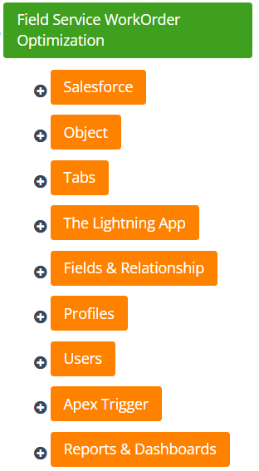

**SALESFORCE**

Creating a Salesforce Developer Edition org allows developers to experiment, innovate, and build customized solutions within a controlled environment. With access to Salesforce's powerful development tools and features, developers can prototype, test, and refine their applications, empowering them to deliver robust and tailored solutions to meet unique business requirements. As a Salesforce Developer for an organization you must have a Salesforce developer edition org in order to do all the required works.

**CREATING ACCOUNT**

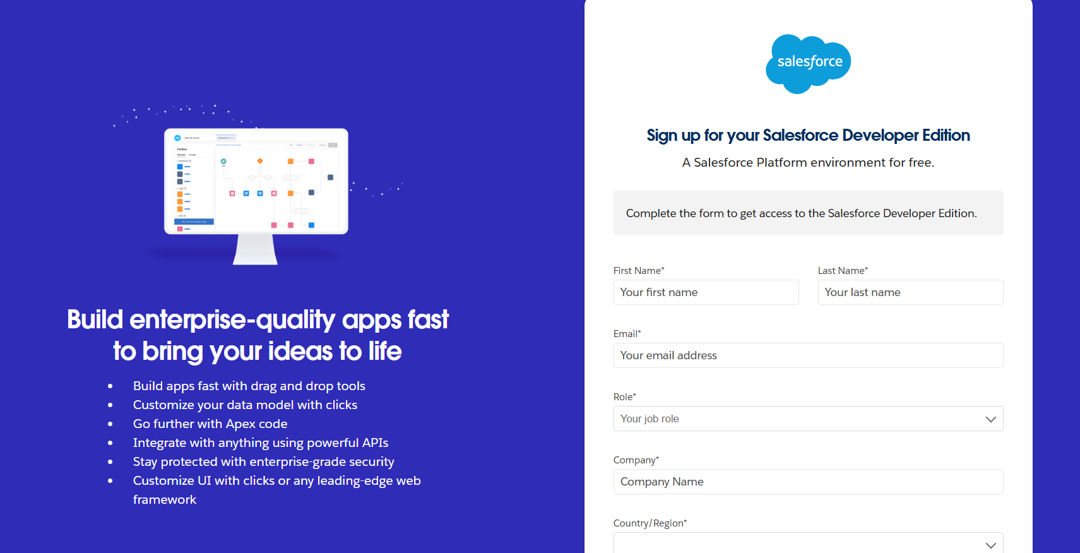

**ACCOUNT ACTIVATION**

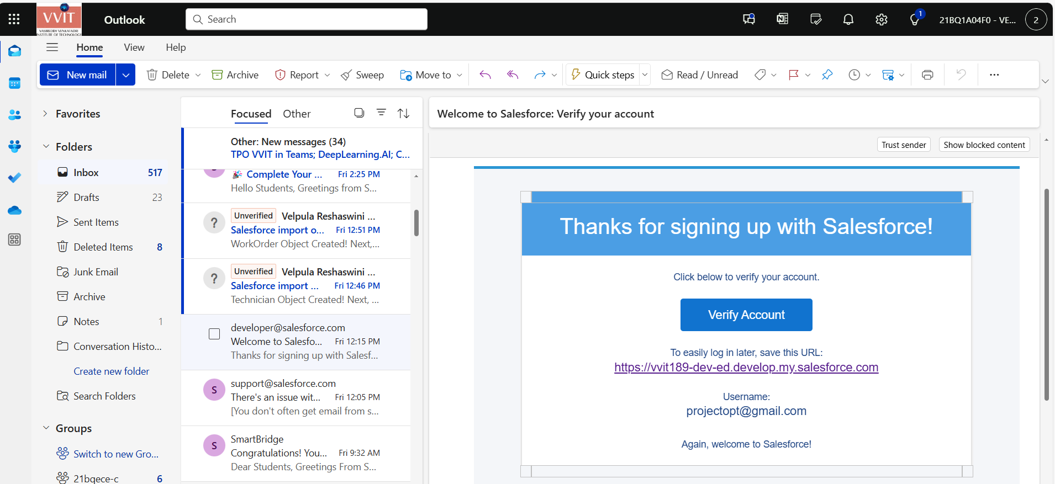

### 

### **OBJECT**

### **To store the data as per business requirement.**

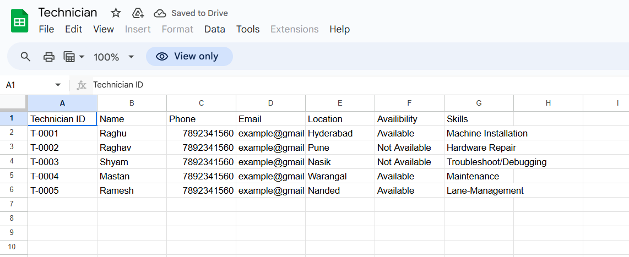

This is the spreadsheet.

### **Tabs**

A tab is like a user interface that is used to build records for objects and to view the records in the objects.

### **The Lightning App**

Well done you have reached close to your organizational requirement by creating the objects to store the organization’s data. Making a database for an organization is just not enough to reach out the requirements, the task is how the users at the organization can access the objects you have created for them

### **Fields & Relationship**

Now it’s time for you to think out of the box for your organization. You have successfully created the database objects for the organization but now all eyes turn on you as you have to define what sort of information the objects store which you have created. As a life saver of your organization you come up with the idea of creating fields to store different types of data.

### **Profiles**

Profile defines what an user is able to do or see in the Salesforce Org

### **Users**

Users are defined as the employees of your organization

### **Apex triggers**

This consists of developer console programs.

### **Reports & Dashboards**

Salesforce Reports and Dashboards are powerful tools that empower users to visualize and analyze data within the Salesforce platform. They play a crucial role in providing insights, monitoring performance, and making informed business decisions.